April 4: Martin Luther King, Jr, Civil Rights Leader and Martyr, 1968
From: http://liturgyandmusic.wordpress.com/2011/04/04/april-4-martin-luther-king-jr-civil-rights-leader-and-martyr-1968/

APRIL 4, 2011 BY JENLANDIS77 22 COMMENTS
Welcome to the Holy Women, Holy Men blog! We invite you to read about this commemoration, use the collect and lessons in prayer, whether individually or in corporate worship, then tell us what you think. For more information about this project, click here.
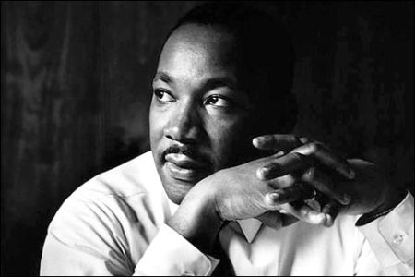

Martin Luther King, Jr. was born on January 15, 1929, in Atlanta. As the son and grandson of Baptist preachers, he was steeped in the Black Church tradition. To this heritage he added a thorough academic preparation, earning the degrees of B.A., B.D., and Ph.D. in Systematic Theology from Boston University.
In 1954, King became pastor of a church in Montgomery, Alabama. There, Black indignation at inhumane treatment on segregated buses culminated in December, 1955, in the arrest of Rosa Parks for refusing to give up her seat to a white man. King was catapulted into national prominence as the leader of the Montgomery bus boycott. He became increasingly the articulate prophet, who could not only rally the Black masses, but could also move the consciences of Whites.
King founded the Southern Christian Leadership Conference to spearhead non-violent mass demonstrations against racism. Many confrontations followed, most notably in Birmingham and Selma, Alabama, and in Chicago. King’s campaigns were instrumental to the passage of the Civil Rights Acts of 1964, 1965 and 1968. King then turned his attention to economic empowerment of the poor and opposition to the Vietnam War, contending that racism, poverty and militarism were interrelated.
King lived in constant danger: his home was dynamited, he was almost fatally stabbed, and he was harassed by death threats. He was even jailed 30 times; but through it all he was sustained by his deep faith. In 1957, he received, late at night, a vicious telephone threat. Alone in his kitchen he wept and prayed. He relates that he heard the Lord speaking to him and saying, “Martin Luther, stand up for righteousness, stand up for justice,” and promising never to leave him alone—“No, never alone.” King refers to his vision as his “Mountain-top Experience.”
After preaching at Washington Cathedral on March 31, 1968, King went to Memphis in support of sanitation workers in their struggle for better wages. There, he proclaimed that he had been “to the mountain-top” and had seen “the Promised Land,” and that he knew that one day he and his people would be “free at last.” On the following day, April 4, he was cut down by an assassin’s bullet.

Collects
I Almighty God, who by the hand of Moses thy servant didst lead thy people out of slavery, and didst make them free at last: Grant that thy Church, following the example of thy prophet Martin Luther King, may resist oppression in the name of thy love, and may strive to secure for all thy children the blessed liberty of the Gospel of Jesus Christ; who liveth and reigneth with thee and the Holy Spirit, one God, now and forever. Amen.
II Almighty God, by the hand of Moses your servant you led your people out of slavery, and made them free at last: Grant that your Church, following the example of your prophet Martin Luther King, may resist oppression in the name of your love, and may secure for all your children the blessed liberty of the Gospel of Jesus Christ; who lives and reigns with you and the Holy Spirit, one God, now and for ever. Amen.
Lessons
Genesis 37:17b-20
Ephesians 6:10-20
Luke 6:27-36
Psalm 77:11-20
Preface of Baptism
From Holy, Women, Holy Men: Celebrating the Saints © 2010 by The Church Pension Fund. Used by permission.
* * *
We invite your reflections about this commemoration and its suitability for the official calendar and worship of The Episcopal Church. How did this person’s life witness to the Gospel? How does this person inspire us in Christian life today?
To post a comment, your first and last name and email address are required. Your name will be published; your email address will not. The first time you post, a moderator will need to approve your submission; after that, your comments will appear instantly.

