Epiphany Star

Your Light is Come

During Advent, the world was in darkness, and we prayed and waited in the spirit of the Jewish nation which lived in expectation of the Coming Light during thousands of years. At Christmas the Light shone forth, but dimly, seen only by a few around the crib: Mary and Joseph and the shepherds. But at Epiphany the Light bursts forth to all nations and the prophecy is fulfilled: "The Gentiles shall walk in Thy light, and kings in the brightness of Thy rising." The mysterious star of Epiphany, "flashing like a flame," is still another facet of the light-motif, a symbol capable of being interpreted in a dozen different ways. (From www.catholicculture.org)

Create these stars during the season of Christmas to have them hanging throughout the season of Epiphany.

Materials needed
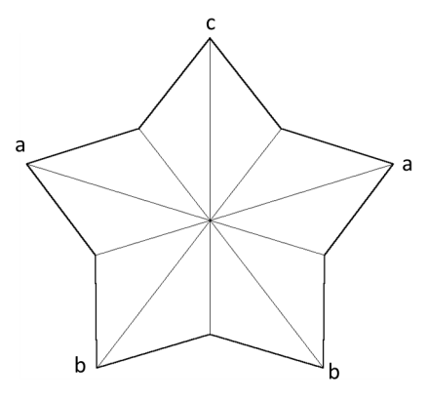
Paper (Any kind of paper will do, though heavy stock is the best. Plain colored card stock or scrapbooking paper is recommended)
Pencil
Scissors
Folding tool (something to help make creases – I usually use a clean butter knife)
Needle
Embroidery floss
String (colorful or plain, gold embroidery floss is fun)

Directions
Folding template
- Cut out the Star Template
- Trace the template onto the back of the paper you’ll use for the stars
- Cut out your stars (fancy scissors also work)
- Using the “folding template” as your example, fold the star.
  - With point “c” at the top, you fold down the middle, connecting point “a” with “a” and point “b” with “b”.
  - The easiest way for me to remember this is that you keep the head of the star at the top, and fold the arms and legs together.
  - After you create on crease, open the star back up and turn the star so there’s a new top point.
  - Continue turning until each point is creased.
Star Template –
cut this star out
- Remember to fold crisply along the lines for a good looking star (using the folding tool)
- Once every line has been creased, refold so that the lines from the middle to the point face the front and the lines from the middle to the non-point face the back. See picture to the right
- Using the needle, poke embroidery floss through the star and make a loop with the floss.
- Tie the loops onto the string and hang around your house.

