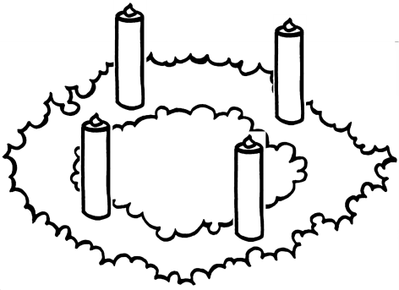
Advent Wreath to Cut and Color

Instructions (of course you can use this any way you’d like, but here is one way)

- Cut out the advent wreath and glue it onto a bigger piece of paper (one that will have room for the candles also)
Use construction paper, scrapbooking paper, or pretty wrapping paper, or use white paper and color it yourself.
You could also do the entire project in felt to make it last for years to come.

- Color the wreath. Traditionally the wreath is green, but you can make it any color you want. The evergreens used in some wreaths represent the everlasting life of Christ. Decorate it with glitter, red dots (for the berries in the evergreens), bows or anything else to make it festive.

- Color the candles and the flames. Traditionally 3 of the candles are purple or blue, one is pink and one is white. With felt, cut out flames and put Velcro on the back.

- Glue Candles on to the wreath. The purple or blue candles are for weeks 1, 2 and 4; week 3 is the pink candle.
The 5th candle, which is white, represents Christmas and often called the “Christ Candle.” Not every church includes this candle.

- Glue a flame over the candle on the Sunday of each week of Advent.

- Say a Prayer. The following one is from the Episcopal Diocese of Texas

Week 1: ALMIGHTY GOD, give us grace to cast away the works of darkness, and put on the armor of light, now in the time of this mortal life in which your Son Jesus Christ came to visit us in great humility; that in the last day, when he shall come again in his glorious majesty to judge both the living and the dead, we may rise to the life immortal; through him who lives and reigns with you and the Holy Spirit, one God, now and forever. Amen.

Week 2: MERCIFUL GOD, who sent your messengers the prophets to preach repentance and prepare the way for our salvation: Give us grace to heed their warnings and forsake our sins, that we may greet with joy the coming of Jesus Christ our Redeemer; who lives and reigns with you and the Holy Spirit, one God, now and forever. Amen.

Week 3: STIR UP YOUR POWER, O Lord, and with great might come among us; and, because we are sorely hindered by our sins, let your bountiful grace and mercy speedily help and deliver us; through Jesus Christ our Lord, to whom, with you and the Holy Spirit, be honor and glory, now and forever. Amen.

Week 4: PURIFY OUR CONSCIENCE, Almighty God, by your daily visitation, that your Son Jesus Christ, at his coming, may find in us a mansion prepared for himself; who lives and reigns with you, in the unity of the Holy Spirit, one God, now and forever. Amen.

Christmas Day: Almighty God, you have given your only-begotten Son to take our nature upon him, and to be born this day of a pure virgin: Grant that we, who have been born again and made your children by adoption and grace, may daily be renewed by your Holy Spirit; through our Lord Jesus Christ, to whom with you and the same Spirit be honor and glory, now and forever. Amen

