The Episcopal Diocese of Western Michigan
2015 Lenten Study Book
Bishop Whayne Hougland invites the people of our diocese
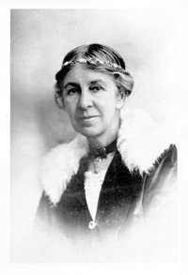
to read Evelyn Underhill's book, Practical Mysticism, this Lent.

Evelyn Underhill was an English Anglo-Catholic writer whose scholarly and spiritual works focused on prayer and mysticism. She lived from 1875 to 1941. Her feast day in the Episcopal Church is June 15th.

Our book of liturgical commemorations, Holy Women, Holy Men: Celebrating the Saints, says of Blessed Evelyn, in part,

Evelyn Underhill’s most valuable contribution to spiritual literature must surely be her conviction that the mystical life is not only open to a saintly few, but to anyone who cares to nurture it and weave it into everyday experience, and also (at the time, a startling idea) that modern psychological theories and discoveries, far from hindering or negating spirituality, can actually enhance and transform it.

In just 100 pages, Underhill presents a practical mysticism which can be nurtured in the life of any Christian. As this little book originally went to press at the beginning of World War I, Underhill dared to assert that mysticism was not escapism or a "soothing draught." She presented mysticism as a powerful stimulant which enables one to better distinguish the real from the illusory, to feel a certitude which cannot be shattered by struggle or catastrophe, and to grow from a deep spiritual consciousness.

We encourage you to gather with a group during Lent and discuss this important book. A set of discussion questions to facilitate these conversations will be forthcoming. The following discussion schedule is one which you may wish to use:

Week beginning February 22nd: Chs. 1 & 2
Week beginning March 1st: Chs. 3 & 4
Week beginning March 8th: Chs. 5 & 6
Week beginning March 15th: Chs. 7 & 8
Week beginning March 22nd: Chs. 9 & 10

The book is currently available in a variety of paperback and digital formats under the titles, Practical Mysticism, or, Practical Mysticism: A Little Book for Normal People.

