St. Lucia (or, St. Lucy)
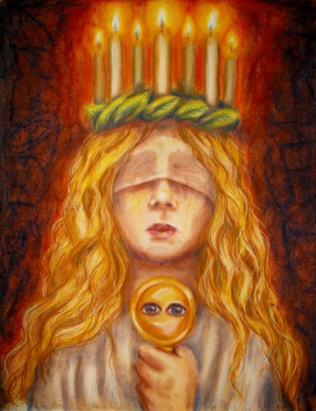
Lucy's feast comes during Advent. Her feast originally coincided with the Winter Solstice, the shortest day of the year before calendar reforms, so her feastday has become a festival of light.
This is particularly seen the in Scandinavian countries, with their long dark winters. There, a young girl dressed in a white dress and a red sash (as the symbol of martyrdom) carries palms and wears a crown or wreath of candles on her head. In Sweden, girls dressed as Lucy carry rolls and cookies in procession as songs are sung. It is said in Sweden that to vividly celebrate St. Lucy's Day will help one live the long winter days with enough light. (from Wikipedia)

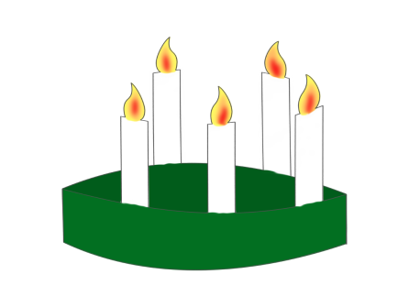
Create a crown of candles

You will need:
- White card-stock paper (which will go through the printer)
- Coloring crayons
- Scissors
- Glue
- Green tissue paper (optional)
- Yellow/red/orange tissue paper (optional)

What to do:
- Print template onto the card.
- Color in and cut out.
- Glue the two pieces together at the short gluing edge.
- Adjust the length to fit head and glue.
- If desired you can cut leaves from green tissue paper to decorate the base.
- If desired cut the flames off and add your own tissue paper flames.
St. Lucia Buns

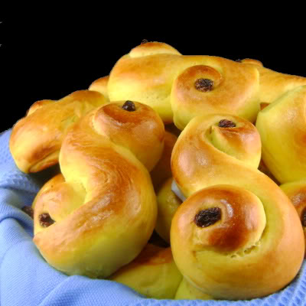
St. Lucia buns may be made ahead of time, frozen, and quickly reheated in the microwave before serving.
Prep Time: 2 hours

Cook Time: 15 minutes

Total Time: 2 hours, 15 minutes

Ingredients:
- 1 cup melted butter
- 1/2 tsp. saffron threads, finely crumbled (or 1 tsp. powdered saffron)
- 1 cup milk
- 3/4 cup sugar
- 1 tsp. salt
- 2 pkg. dry active yeast (4 1/2 tsp)
- 6 1/2 cups all-purpose flour
- 2 eggs, well-beaten, plus one egg white
- raisins or currants to decorate
Preparation:

Crumble saffron threads into melted butter. Let sit 30 minutes to an hour (this intensifies the saffron flavor).

Heat milk to a light boil, turning off heat when it reaches the scalding point (with small bubbles across the top). Stir in melted butter, sugar, and salt. Pour mixture into mixing bowl and allow to cool until “finger-warm” (still quite warm, but just cool enough to touch). Stir in yeast and let sit for 10 minutes.

Mix 3 1/2 cups flour into liquid. Stir in two well-beaten eggs. Add enough of the remaining flour to form a soft dough (just until the dough pulls away from the sides of the bowl. You don't want to add too much flour).

Transfer dough to a large greased bowl and turn to coat all sides. Cover with a clean towel and allow to rise until doubled, about 1 hour.

Punch down risen dough. Lightly knead two or three times on a floured surface. Pinch off small handfuls of dough (about the size of a racquetball) and roll into "snakes." Shape snakes into "S"-shaped buns or other desired shapes (please see my photo gallery of Lucia buns for traditional examples). Place on a lightly greased baking sheet, cover with the towel again, and allow to rise until doubled (about an hour).

Decorate buns with raisins, brush with egg white, and bake in preheated 375º oven about 15 minutes, just until brown. Yield: 20 St. Lucia Buns ("Lussekatter")

From about.com

