Guidelines for Appropriate Affection

The Diocese of Western Michigan is committed to creating and promoting a positive, nurturing environment for our children and youth ministries that protect our children and youth from abuse and our adult staff from misunderstandings. When creating safe boundaries for children and youth, it is important to establish what types of affection are appropriate and inappropriate. Stating which behaviors are appropriate and inappropriate allows adult staff to comfortably show positive affection in ministry, and yet identify individuals who are not maintaining safe boundaries with children or youth.

These Guidelines are based, in large part, on avoiding behaviors known to be used by child molesters to groom children or youth and their parents for future abuse. The following guidelines are to be carefully followed by all Church Personnel working around or with children or youth.

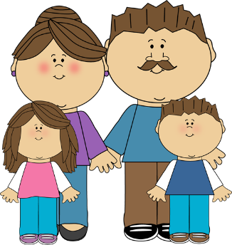
www.mycutegraphics.com

Appropriate boundaries
Love and affection are part of church life and ministry. There are many ways to demonstrate affection while maintaining positive and safe boundaries with children and youth.
Some positive and appropriate forms of affection are listed below:
- Brief hugs
- Pats on the shoulder or back
- Handshakes
- “High-fives” and hand slapping
- Verbal praise
- Touching hands, faces, shoulders and arms of children or youth
- Arms around shoulders
- Holding hands while walking with small children
- Sitting beside small children
- Kneeling or bending down for hugs with small children
- Holding hands during prayer
- Pats on the head when culturally appropriate

Inappropriate Boundaries
The following forms of affection are considered inappropriate with children and youth in ministry setting because many of them are the behaviors that child molesters use to groom children or youth and their parents for later molestation or can be, in and of themselves, sexual abuse.
- Inappropriate or lengthy embraces
- Kisses on the mouth
- Holding children over three years old on the lap
- Touching bottoms, chests or genital areas other than for appropriate diapering or toileting of infants and toddlers
- Showing affection in isolated areas such as bedrooms, closets, staff only areas or other private rooms
- Occupying a bed with a child or youth
- Touching knees or legs of children or youth
- Wrestling with children or youth
- Tickling children or youth
- Piggyback rides and carrying children over three years old
- Any type of massage given by a child or youth to an adult
- Any type of massage given by an adult to a child or youth
- Any form of unwanted affection
- Swearing or making suggestive comments to children or youth
- Comments or compliments (spoken, written, or electronic) that relate to physique or body development.
Examples would be, “You sure are developing,” or “You look really hot in those jeans”
- Snapping bras or giving wedgies or similar touch of underwear whether or not it is covered by other clothing
- Giving gifts or money to individual children or youth
- Private meals with individual children or youth

