Gift bags

Put together these gift bags and fill them with treats (both sugary treats and fun puzzles and projects). They can be given to people in your community or local charities.
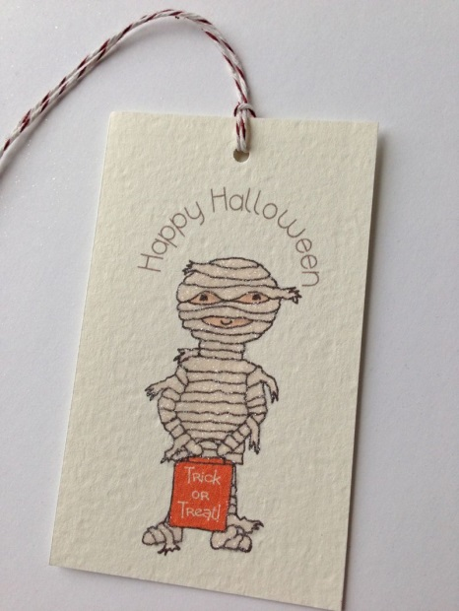
Supplies
Scissors
Gift bags
Tags
Supplies to fill

Directions
Gift bag: Print and copy one of the pages. You can also change the picture to be one of your own. You will need two pages for each bag. Cut out around outer edge and up dotted line. Glue the side flap and the bottom pieces together to make a bag.

Collect treats to go inside and fill bags: The sugary kind are always fun, but you can also include word search puzzles, coloring pages, crayons, pencils and many other things.

Gift tags: change the text and picture as you want. Print them out and copy. Cut and put one into each bag.

You can do this by assembly line, with some people cutting, some gluing, and some filling. We found the best way is to assemble the bags and then line them up on a tray. Then move the entire tray full of bags from station to station. That way the glue can take time to set while you fill them.

As a reminder – always contact the organization that you want to donate things to. Make sure everything’s alright ahead of time, get a supply list for things they might want in there (or offer your supply list for approval) and set up the best time to deliver them. Adhere to any wishes they have.

Compiled by Ms. Genevieve Callard and The Rev. Christine Tillman, Deacon, The Episcopal Diocese of Western Michigan. Artwork and prayers found on the internet – for most of them, the copyrights unknown. If any copyrighted material was mistakenly used, I do apologize and will change or remove it as I am told. Thank you for understanding!
May be copied and used appropriately for nonprofit educational purposes.
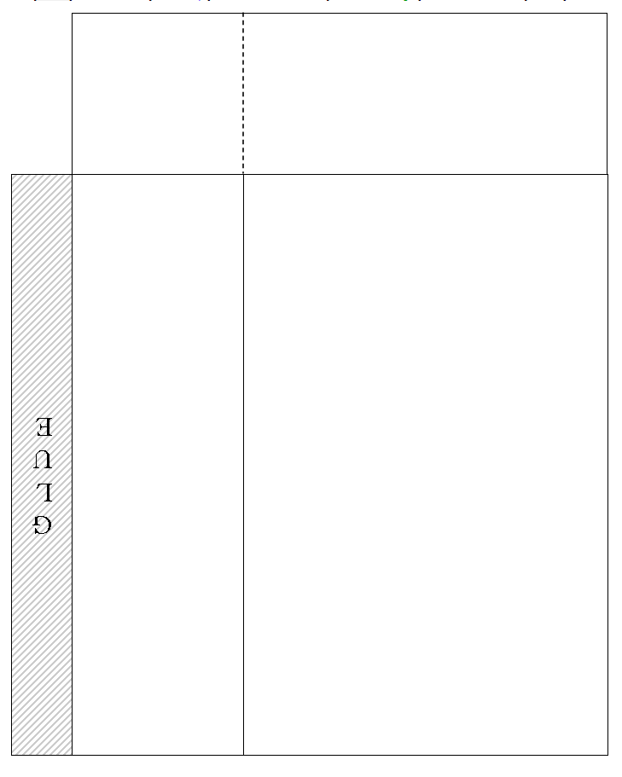
THINKING OF YOU. HAVE FUN THIS HALLOWEEN FROM | THINKING OF YOU. HAVE FUN THIS HALLOWEEN FROM
THINKING OF YOU. HAVE FUN THIS HALLOWEEN FROM | THINKING OF YOU. HAVE FUN THIS HALLOWEEN FROM

