Keep Awake!
Reflections for the First Sunday of Advent Year B

Scripture
"But about that day or hour no one knows, neither the angels in heaven, nor the Son, but only the Father. Beware, keep alert; for you do not know when the time will come. It is like a man going on a journey, when he leaves home and puts his slaves in charge, each with his work, and commands the doorkeeper to be on the watch. Therefore, keep awake-- for you do not know when the master of the house will come, in the evening, or at midnight, or at cockcrow, or at dawn, or else he may find you asleep when he comes suddenly. And what I say to you I say to all: Keep awake." (Mark 13:35-37)

Reflection
Imagine that someone important to you is going to arrive soon, but you don’t know when. You have been waiting all day. Now it’s night. Feel how tired you are. You wonder how much longer you must wait. You want to be away when the guest comes, but your eyes get heavier and heavier.
- What makes staying awake so hard?
- What’s the hardest part of waiting for you?
- What do you do when you have to wait for something?
- If the person arrived while you were asleep, how might you feel?

Our Daily Life
Jesus used the example of a homeowner going away to help people think about how important it is to say ready for his return. In Jesus’ story, what were the servants supposed to do while the owner was gone?
- What kinds of things do you and your family have to stay ready and prepare for?

Lighting the Candle
We light the first candle of Advent today, remembering to keep awake and watch for Jesus’ coming.

Stir up our hearts, we beseech you, to prepare ourselves to receive your Son. When he comes and knows, may he find us not sleeping in sin, but away to righteousness, ceaselessly rejoicing in his love. May our hearts and minds be so purified, that we may be ready to receive his promises of eternal life.
(The Gelasian Sacramentary, c. 500)

Daily Thought
Where did you experience God’s love today?
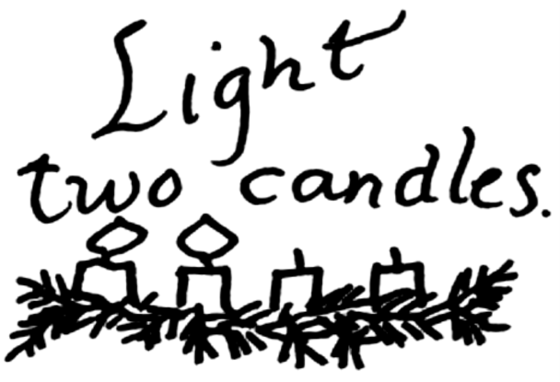
Get Ready!
Reflections for the Second Sunday of Advent Year B

Scripture
As it is written in the prophet Isaiah,
"See, I am sending my messenger ahead of you, who will prepare your way; the voice of one crying out in the wilderness:
`Prepare the way of the Lord, make his paths straight,'"
John the baptizer appeared in the wilderness, proclaiming a baptism of repentance for the forgiveness of sins. And people from the whole Judean countryside and all the people of Jerusalem were going out to him, and were baptized by him in the river Jordan, confessing their sins. Now John was clothed with camel's hair, with a leather belt around his waist, and he ate locusts and wild honey. He proclaimed, "The one who is more powerful than I is coming after me; I am not worthy to stoop down and untie the thong of his sandals. I have baptized you with water; but he will baptize you with the Holy Spirit." (Mark 1:1-8)

Reflection
Imagine who John was in relationship to Jesus.
- Why do you think John wanted people to get ready for Jesus?
- Why do you suppose so many people wanted to be baptized by John?
- How is John getting the people ready to celebrate the birth of Jesus?

Our Daily Life
Today we listen to John’s message as we get ready to celebrate the birth of Jesus.
- How do we get ready for Jesus’ arrival today?

Lighting the Candles
As we light the second candle of Advent we are reminded again that we are getting ready for the arrival of Jesus in our lives.

Father in heaven, the day draws near when the glory of your Son will make radiant the night of the waiting world. May the lure of greed not impede us from the joy which moves he hears of those who seek him. May the darkness not blind us to the visions of wisdom which fills the minds of those who find him.
(Traditional: Roman rite)

Daily Thought
How have you spread God’s joy today?

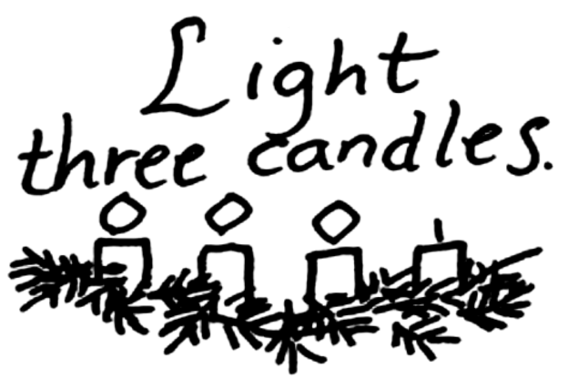
Good News Coming!
Reflections for the Third Sunday of Advent Year B

Scripture
This is the testimony given by John when the Jews sent priests and Levites from Jerusalem to ask him, "Who are you?" He confessed and did not deny it, but confessed, "I am not the Messiah." And they asked him, "What then? Are you Elijah?" He said, "I am not." "Are you the prophet?" He answered, "No." Then they said to him, "Who are you? Let us have an answer for those who sent us. What do you say about yourself?" He said, "I am the voice of one crying out in the wilderness, `Make straight the way of the Lord,'" as the prophet Isaiah said. Now they had been sent from the Pharisees. They asked him, "Why then are you baptizing if you are neither the Messiah, nor Elijah, nor the prophet?" John answered them, "I baptize with water. Among you stands one whom you do not know, the one who is coming after me; I am not worthy to untie the thong of his sandal."
(John 1:6-8,19-28)

Reflection
Sometimes good news comes in strange ways, and from strange people
- What good news did John bring?
- What is good about the news for people who live today?
- What is good about the news for you?

Our Daily Life
Today we recognize the good news of the coming of Christ.
- How would you live your life differently if you thought that each da would bring good news?

Lighting the Candles
We light the third candle of Advent today, remembering that Jesus is God’s good news, and that the good news is coming.

Good news; but if you ask me what it is, I know not; It is a track of feet in the snow, It is a lantern showing a path, It is a door set open.
(G. K. Chesterton)

Daily Thought
What good things did you see today?

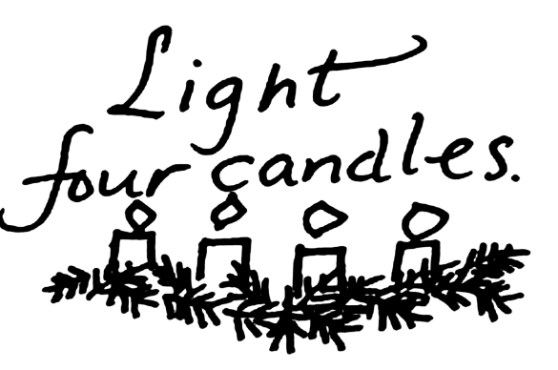
Greetings, Favored One!
Reflections for the Fourth Sunday of Advent Year B

Scripture
In the sixth month the angel Gabriel was sent by God to a town in Galilee called Nazareth, to a virgin engaged to a man whose name was Joseph, of the house of David. The virgin's name was Mary. And he came to her and said, "Greetings, favored one! The Lord is with you." But she was much perplexed by his words and pondered what sort of greeting this might be. The angel said to her, "Do not be afraid, Mary, for you have found favor with God. And now, you will conceive in your womb and bear a son, and you will name him Jesus. He will be great, and will be called the Son of the Most High, and the Lord God will give to him the throne of his ancestor David. He will reign over the house of Jacob forever, and of his kingdom there will be no end." Mary said to the angel, "How can this be, since I am a virgin?" The angel said to her, "The Holy Spirit will come upon you, and the power of the Most High will overshadow you; therefore the child to be born will be holy; he will be called Son of God. And now, your relative Elizabeth in her old age has also conceived a son; and this is the sixth month for her who was said to be barren. For nothing will be impossible with God." Then Mary said, "Here am I, the servant of the Lord; let it be with me according to your word." Then the angel departed from her. (Luke 1:26-38)

Reflection
It’s believed that Mary was about 14 when she became a mother. Imagine what how Mary felt when she decided to do this.
- How did God surprise Mary? How was Mary’s life changed by that surprise?
- What might Mary have said to Joseph after Gabriel’s visit?
- What might Joseph have said to her?

Our Daily Life
God wants us to feel that God is with us and loves us always, making us God’s favored one.
- How has God surprised you?

Lighting the Candles
We light the fourth candle of Advent remembering that God brings surprises into our lives. In this way we too are favored ones of God.

The glory of God is a living person and the life of each living person is the vision of God. (Irenaeus of Lyon, Second century)

Daily Thought
How were you surprised today?

Advent Week 1 John 1:6-8,19-28

We light the first candle of Advent today, remembering to keep awake and watch for Jesus’ coming.

Pray: Stir up our hearts, we beseech you, to prepare ourselves to receive your Son. When he comes and knows, may he find us not sleeping in sin, but away to righteousness, ceaselessly rejoicing in his love. May our hearts and minds be so purified, that we may be ready to receive his promises of eternal life. (The Gelasian Sacramentary, c. 500)

Reflect: Where did you experience God’s love today?

+++++++++++++++++++++++++++++++++++++++++++++++++++++++++++++++++++

Advent Week 2 Mark 1:1-8

As we light the second candle of Advent we are reminded again that we are getting ready for the arrival of Jesus in our lives.

Pray: Father in heaven, the day draws near when the glory of your Son will make radiant the night of the waiting world. May the lure of greed not impede us from the joy which moves he hears of those who seek him. May the darkness not blind us to the visions of wisdom which fills the minds of those who find him. (Traditional: Roman rite)

Reflect: How have you spread God’s joy today?

+++++++++++++++++++++++++++++++++++++++++++++++++++++++++++++++++++

Advent Week 3 John 1:6-8,19-28
We light the third candle of Advent today, remembering that Jesus is God’s good news, and that the good news is coming.

Pray: Good news; but if you ask me what it is, I know not; It is a track of feet in the snow, It is a lantern showing a path, It is a door set open. (G. K. Chesterton)

Reflect: What good things did you see today?

+++++++++++++++++++++++++++++++++++++++++++++++++++++++++++++++++++
Advent Week 4 Luke 1:26-38

We light the fourth candle of Advent remembering that God brings surprises into our lives. In this way we too are favored ones of God.

Pray: The glory of God is a living person and the life of each living person is the vision of God. (Irenaeus of Lyon, Second century)

Reflect: How were you surprised today?

