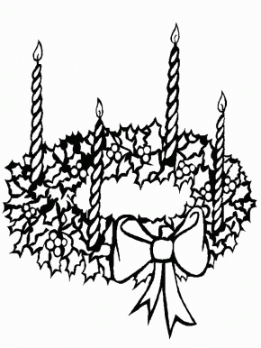**Advent 1**

First Sunday of Advent

Advent Wreath

Everlasting Life

“O eternal God, the beginning and the end, you who sustain all things, understand all things, who existed before all things, and who are without end, be with us, remain among us; strengthen our intentions, sanctify our souls and eradicate in us all that is evil. Enable us to make a good sacrifice and pour out your abundant blessings, and so enable us to enter into the holy of holies wherein dwells your presence.” ~Ethiopian liturgy



**Advent 2**

Anchor

Hope

“Goodness is stronger than evil;

Love is stronger than hate;

Light is stronger than darkness;

Life is stronger than death;

Vistory is ours through Him who loves us.” ~Desmond Tutu

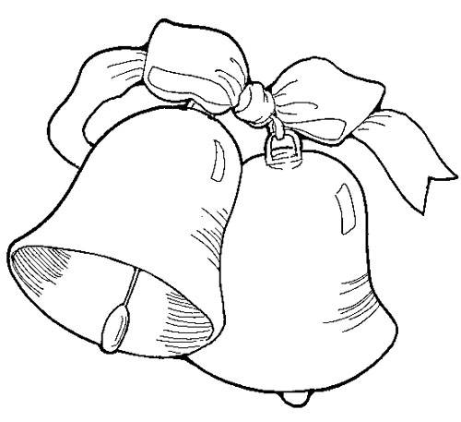**Advent 3**

Bells

Worship

“Let all the earth bow to you and sing to you,

Let all sing your name Most High.” ~Orthodox Liturgy

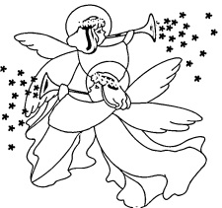**Advent 4**

Angels

Announcing

“Tell the timid to take heart.

The Lord our God will come!” ~Monastic liturgy

**Advent 5**

Christmas ornament – round

Eternity and endlessness

“The earth is your mother, she holds you.

The sky is your father, he protects you.

Sleep, sleep.

Rainbow is your sister, she loves you.

The winds are your brothers, they sng to you.

Sleep, sleep.

We are together always.

We are together always.

There never was a time when this was not so.”

~Native American song

**Advent 6**

St. Nicholas Day

Santa Claus

Giving

“God of joy and cheer, we thank you for your servant, the good bishop Nicholas.

In loving the poor, he showed us your kindness;

in caring for your children, he revealed your love.

Make us thoughtful without need of reward so that we, too, may be good followers of Jesus. ~ David B. Batchelder

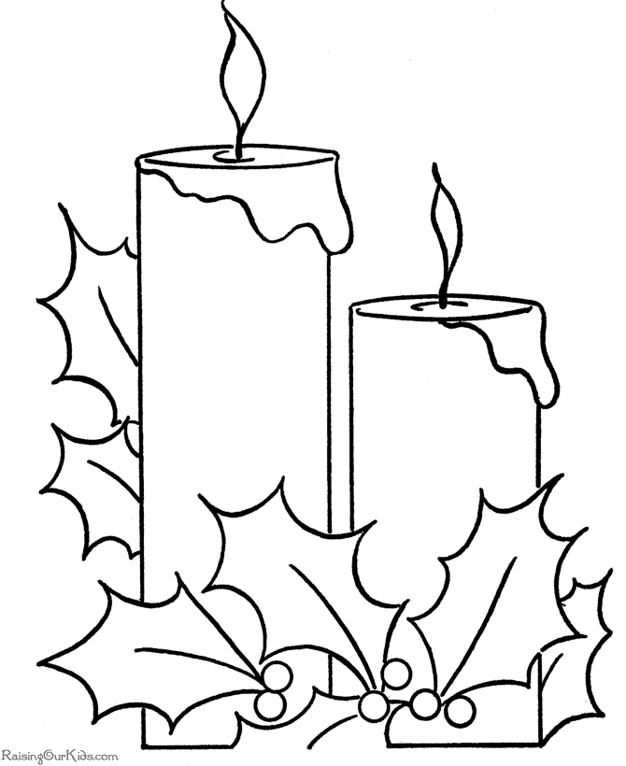**Advent 7**

Lanterns (or Candles)

Jesus is the light of the world

“Good news; but if you ask me what it is, I know not;

It is a track of feet in the snow,

It is a lantern shoing a path,

It is a door set open.” ~G. K. Chesterton

**Advent 8**

Second Sunday of Advent

Bethlehem (or heart)

Love

“Because of his boundless love, Jesus became what we are that he might make us to be what he is.”

~Irenaeus, Third century

**Advent 9**

Book

Jesus is the word made flesh

“There is one God, whose word and wisdom made and ordered all things. God’s word is our Lord Jesus Christ who in these last times became human among humankind, that Christ might unite the end with the beining, that is, humankind with God.”

~Irenaeus of Lyon, Second century

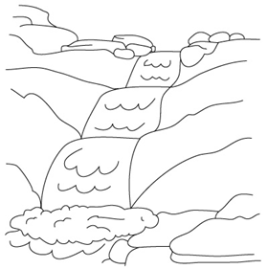**Advent 10**

River

John the Baptist

“On Jordan’s bank the Baptist’s cry

Announces that the Lord is nigh;

Awake and harden, for he brings

Glad tidings of the King of kings.”

~Charles Coffin, Eighteenth Century

**Advent 11**

Star

Following the star – guiding our way

“Christ is the Morning Star, who, when the night of this world is past, gives to his saints the promise of the light of life, and opens everlasting day.

~Venerable Bede, Eighth century

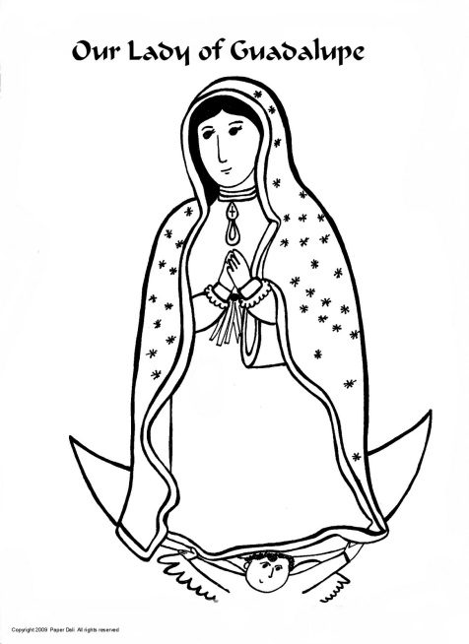**Advent 12**

Our Lady of Guadalupe Day

A woman

Violence against women

“That man say we can’t have as much rights as a man ‘cause Christ wasn’t a woman. Where did your Chirst come from? From God and a woman. Man had nothing to do with it.” ~Sojourner Truth, Nineteenth century

**Advent 13**

St. Lucy Day

Eyeglasses

Sight to the blind, seeing new things

“My candle burns at both ends;

It will not last the night;

But ah, my foes, and oh, my friends –

It give a lovely light!”

~Edna St. Vincent Millay

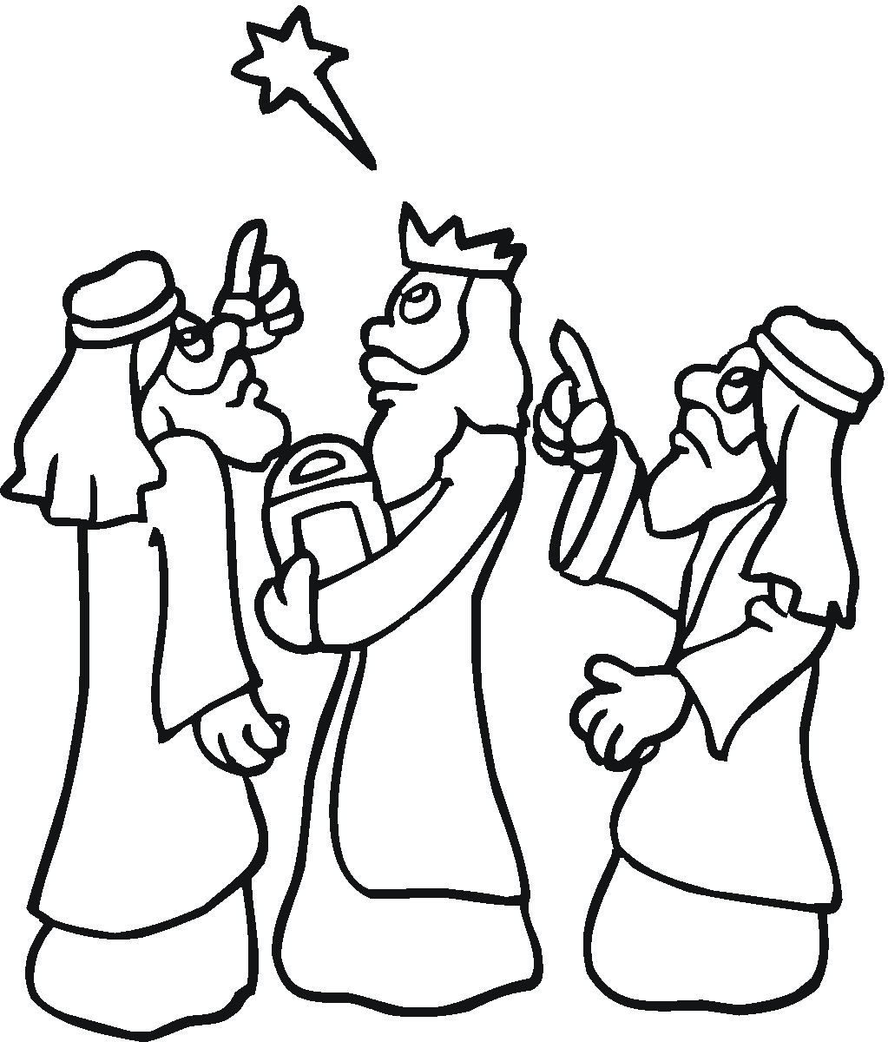**Advent 14**

Wisemen

Setting off on the journey to search for God

“The gifts of God are multiplied, and we in our time experince all that the first believers did. For though the gospel account tells us only of the days when three men, untaught by prophetic preaching or the testimonies of the Law, came from the distant East in order to know God, yet we see the same thing happening now even more clearly and on a far larger scale in the enlightenment of all who are called.” ~Leo the Great, Fifth century

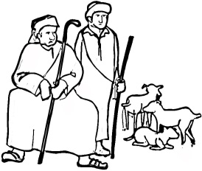**Advent 15**

Third Sunday of Advent

Shepherd

Joy – finding joy in our every-day tasks

“As not, doubt not. You have, my heart, already chosen the joy of Advent. As a force against your own uncertainty, bravely tell yourself, ‘It is the Advent of the great God.’ Say this with faith and love, and then both the past of your life, which has become holy, and your life’s eternal, boundless future will draw together in the now of this world. For then into the heart comes the one who is Advent, the boundless future who is already in the process of coming, the Lord, who has alread come into the time of the flesh to redeem it.” ~Karl Rahner

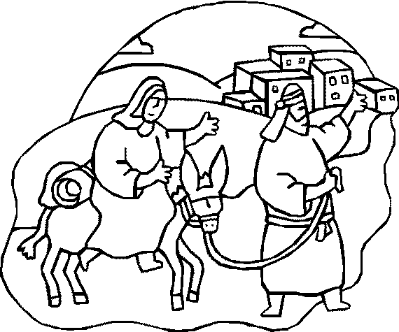**Advent 16**

Mary & Joseph traveling

Immigrants, immigration & finding a new life

“See! The ruler of the earth shall come, the Lord who will take from us the heavy burden of our exile.”

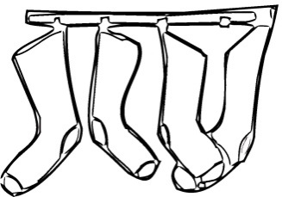**Advent 17**

Orange (or Christmas stocking)

Giving (gold or money)

“God saw the world falling to ruin because of fear and immediately acted to call it back with love. God invited it by grace, preserved itby love, and embraced it with compassion.” ~Peter Chrysologus, Fifth century

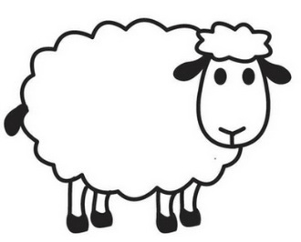**Advent 18**

Sheep

Innocence and gentleness

“If you think you can bring your people back into the fold by making them suffer, then I, Leib, son of Rachel, swear to you that you will not succeed. So why try? Save your children by giving them joy, by delivering them. By doing it that way, you have nothing to lose and everything to gain.” ~Hasidic tale told by Elie Wiesel

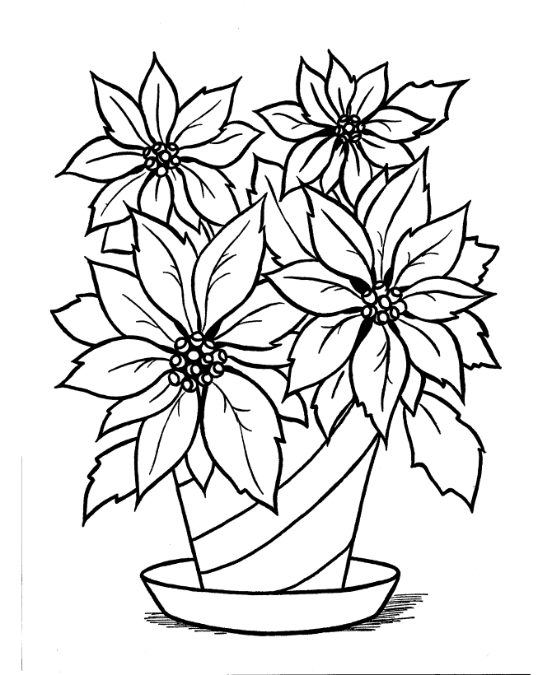**Advent 19**

Poinsettia

Giving what we can (Mexican tradition – 16th century)

“Almighty God, whose loving hand has given us all that we possess: Grant us grace that we may honor you with our

substance, and, remembering the account which we must one day give, may be faithful stewards of your bounty, through Jesus Christ our Lord. Amen.”

~Book of Common Prayer

**Advent 20**

Musical notes or instruments

Music brings us close to God

“This morning to ward off the noise I have my radio on – Berlioz, Schubert, Chopin, etc. It is not a distraction, it is a pacifier. As St. Teresa of Avila said as she grabbed her castanets and started to dance during the hour of recreation in her unheated convent, ‘One must do something to make life bearable!’” ~ Dorothy Day

Advent 21

Winter Solstice

Moon

The Longest night of the year

“O Morning Star, O radiant Dawn,

When will we sing your morning song?

Come, Son of God! Without your light

We grope in dread and gloom of night.”

~Friedrich von Spee, Seventh centrury



Advent 22

Fourth Sunday of Advent

Dove

Peace

“It is only together as the Body of Christ that we can hope to find healing, reconciliation, and genuine and lasting peace.”

~The Most Rev. Katharine Jefferts Schori

Advent 23

Sun

Light begins to overcome the darkness

“The Lord will come soon, will not delay.

The Lord will make the darkest places bright.”

~Monastic liturgy

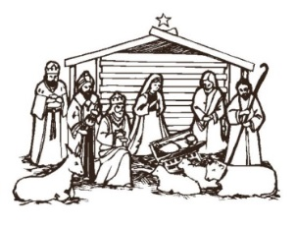

**Advent 24**

Crèche

Humility

“No one can celebrate a genuine Christmas without being truly poor. The self-sufficient, the proud, those who, because they have everything, look down on others, those who have no need even of God – for them there will be no Christmas. Only the poor, the hungry, those who need someone to come on their behalf, will have that someone. That someone is God, Emmanuel, God-with-us. Without poverty of spirit there can be no abundance of God.”

~Oscar Romero

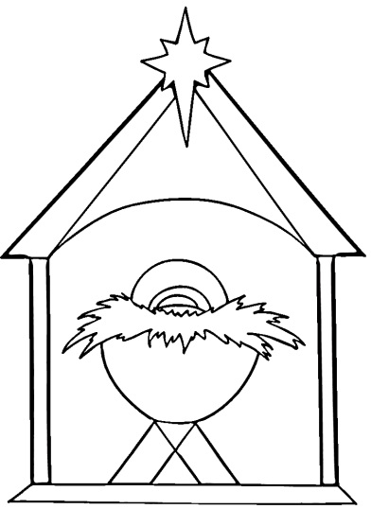

**Christmas Day**

Baby Jesus

New life

“Good News and great joy to all the world: Today is born our savior, Christ the Lord.”

~Mass at Midnight, Roman rite

*Compiled by Ms. Genevieve Callard and The Rev. Christine Tillman, Deacon, The Episcopal Diocese of Western Michigan. Artwork and prayers found on the internet – for most of them, the copyrights unknown. If any copyrighted material was mistakenly used, I do apologize and will change or remove it as I am told. Thank you for understanding!*

*May be copied and used appropriately for nonprofit educational purposes.*